REGISTRATION FORM
Spring Meeting Paris 2019
28 May 9.30-17.00
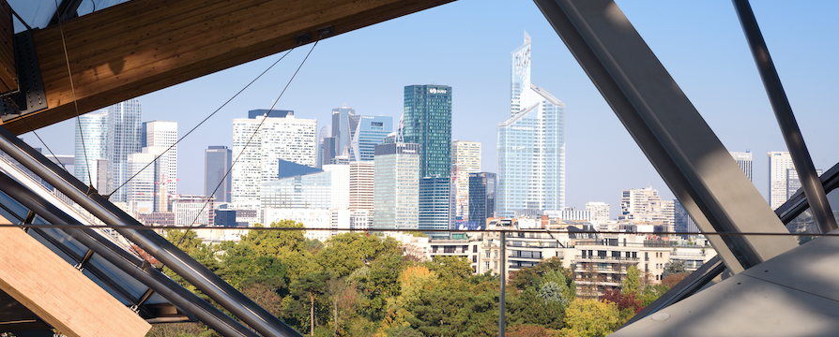

Please send the form to patrick@european-nutrition.org.
Every country delegation is invited to send one representative to the Spring Meeting who will have their travel cost and meals covered by ENHA but are asked to make their own accommodation arrangements. Country delegations are welcome to bring additional delegates. However, we ask that they make their own travel and accommodation arrangements.

Special hotel room offer
We have managed to negotiate a special offer for a room on 27 May at hotels Bedford and L’ Arcade located both at Rue de l’Arcade, within 500 meters of the venue. €260 for a Classic room at L' Arcade and €379 for a DeLuxe room at Bedford. If you wish to redeem this offer, please make your reservation *** BEFORE APRIL 26 *** with Nadine Munka at nmunka@hotel-bedford.com (please mention Optimal Nutritional Care for All).
Reimbursement
As the rooms are still quite costly (due to Roland Garros and other events) ENHA reimburses €100,- of the hotel cost on 27 May plus travel costs and meals for 1 delegate per country.

Yes, I would like to attend:
The Dinner The Spring Meeting
Paris 27 May Paris 28 May

- Full name
- Email address
- Job title and organisation

- Nationality
- Special dietary requirements
- Accessibility requirements

Additional Delegate’s Details
I would like to invite additional delegate(s) from my country group. I understand that this delegate has been asked to make their own arrangements.
The Dinner The Spring Meeting
Paris 27 May Paris 28 May

- Full name
- Email address

- Job title and organisation
- Nationality
- Special dietary requirements
- Accessibility requirements

